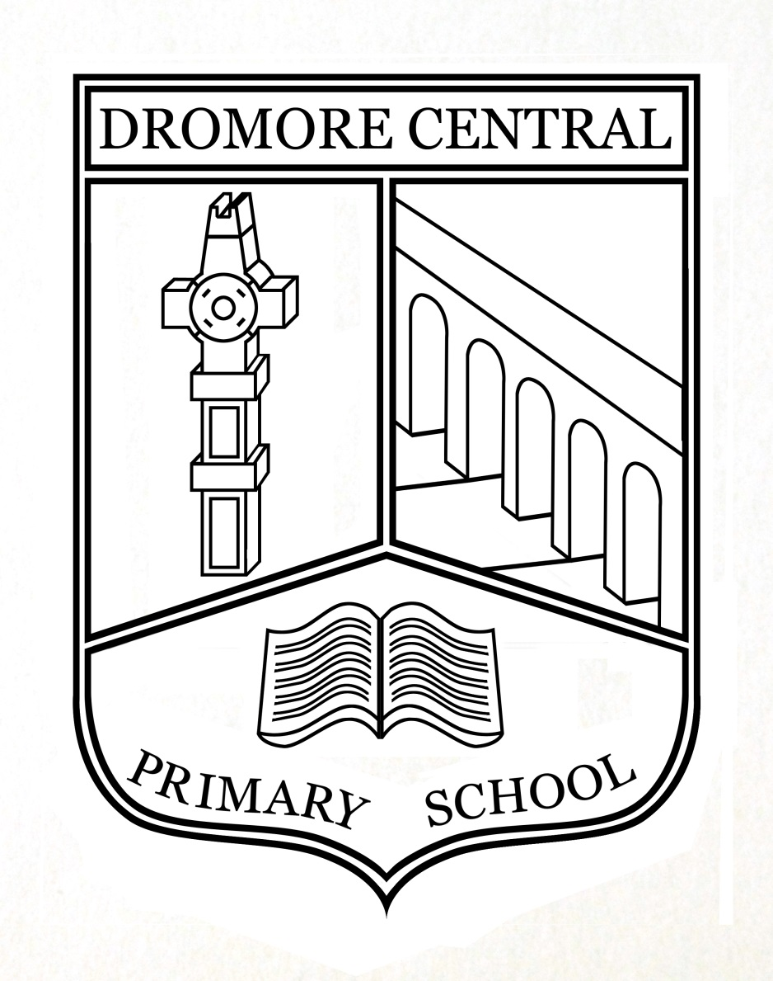

Interview Record

Dromore Central Primary School

ICT Policy

Reviewed June 2023

Table of Contents

- Dromore Central Primary School ICT Vision Page 3
- General Statement Page 4
- Rationale Page 4
- Aims Page 4
- Strategies for use of ICT Page 5
- Planning and Progression Page 5
- Access and Resources Page 5
- Inclusion Page 6
- Internet Page 6
- ICT and the Northern Ireland Curriculum Page 6
- PROGRESSION, Monitoring, Assessing and Evaluating Page 7
- ICT Co-ordinators Page 8
- School Development Plan Page 8
- Staff Development Page 9
- Health and Safety Page 9
- Blended Learning Page 10
- Sanctions Page 11
- Review Page 11

ICT Policy
Ratified by Board of Governors (Date)_____________
Signed : __________________________________________
Review Date : June 2023
Dromore Central Primary School ICT Vision

At Dromore Central Primary School our vision is to create motivated, ‘life-long’ learners through the use of ICT, to enhance and extend learning and teaching across the whole curriculum. As ICT is continually developing and new technologies emerging, we, as a school, will strive to give all pupils the skills to prepare them for a future in which ICT is an integral part of society. Dromore Central Primary School will provide a broad, balanced and differentiated curriculum.

Our vision encompasses the following aims:
- To embed ICT into everyday school life by enabling pupils to explore, express, exchange, evaluate and exhibit their work.
- To provide opportunities to enable all our staff and pupils to be confident, competent and independent users of ICT.
- To provide an environment where access to ICT resources is natural and common place.
- To ensure ICT has a fundamental role in the developing and enhancing our school’s key learning aims in promoting the pupils’ educational, physical and social needs.
- To use ICT to develop the school website, showcasing learning and sharing resources between pupils, staff, parents, Board of Governors, other schools and the wider community.

General Statement
At Dromore Central Primary School we recognise the importance of ICT in the primary school curriculum. We believe it is a life skill that ranks alongside basic literacy and numeracy. We feel that it is our duty to provide staff and pupils in this school with the opportunity to develop the ICT capabilities and competences.
ICT comprises a variety of systems that handle electronically retrievable information. These include computers, laptops, digital resources, Interactive Whiteboards, floor robots, iPads and digital cameras. ICT is concerned with the handling of electronic information and involves creating, collecting, holding, processing, presenting and communicating this information in a variety of ways for a variety of purposes.
Using Information and Communications Technology (UICT) is one of three cross curricular skills in the Northern Ireland Curriculum, with an emphasis on the use of ICT resources to enhance and enrich all areas of learning.

Rationale
Why should our pupils use ICT?
- ICT can enhance and enrich the learning process across all areas of the curriculum.
- ICT can motivate and enthuse pupils.
- ICT allows pupils to explore and manage relevant information.
- ICT promotes independence in learning and has the potential to improve pupils’ thinking skills.
- ICT can empower pupils, develop self-esteem and promote positive attitudes to learning.
- ICT gives pupils the opportunity to exhibit and showcase their learning.
- ICT allows opportunities for review and reflection.
- ICT offers potential for effective group work and collaborative learning.
- ICT supports different types of learners – audio, visual and kinaesthetic.

Aims
Our aims in using ICT are to:
- Extend and enhance learning across all areas of the curriculum.
- Enable pupils to select and use ICT appropriate to their task.
- Develop practical skills in the use of ICT and the ability to apply these skills to the solving of relevant and worthwhile problems.
- Give children access to a variety of sources of information.
- Instil in children a sense of confidence, achievement and enjoyment.
- Enable pupils to extend their learning beyond the school environment.
- Use ICT as a means of communicating their learning.
- Promote the use of ICT by staff for planning and communicating.
- Enable pupils to develop the skills of using ICT safely and responsibly in a safe learning environment.

Our aims in using ICT in Management are to:
- Create, use and adapt high quality digital teaching resources to prepare children for the technological world they live in.
- Support communication with parents and the wider school community.
- Enable and support the sharing of resources and good practice through ICT.
- Increase professional efficiency through the use of ICT systems for planning, record keeping, reporting and communicating.
- Enable the use of pupil performance data to inform strategic planning in Numeracy and Literacy.

Strategies for use of ICT
- Since the focus of the Northern Ireland Curriculum is now on ‘Using’ ICT skills, ICT is not taught as a distinct subject, but is a tool to be used in a variety of meaningful contexts throughout the curriculum. ICT should be integrated into each area of study to support and enrich children’s learning.
- All pupils are given equal access opportunities through management of ICT resources.
- ICT is offered as an entitlement for all pupils – it should not be perceived as a punishment or reward.
- ICT is used to enhance learning through whole class, group and individual work.
- ICT is used to extend learning beyond the classroom.

Planning and Progression
- Planning for ICT ensures coverage of the statutory requirements for ICT as set out under the 5 ‘E’s – Explore, Express, Exchange, Evaluate and Exhibit. ICT co-ordinators ensuring progression shown on planners from Year 1 to Year 7.
- All pupils have opportunities to develop a wide range of skills and competencies, within their age and ability range, as they progress through the school from Year 1 to Year 7.
- Teachers have received training on the statutory requirements of the 5 ‘E’s and the levels of progression within each one.

Access and Resources
- Staff and Pupils have access to ICT through a network and wireless system.
- Staff and Pupils have access to ICT through class-based computers, laptops and iPads.
- A timetable is provided for use by Year 3 and Year 4 for their ICT area.
- A timetable is provided for use by Year 5 to Year 7 for their ICT area.
- 29 IWBs and 4 panel boards installed throughout the school.
- 257 iPads. 1 teacher and 9 pupil iPads, per classroom with 10 for SEN and 10 for a spare Class Set. All iPads are controlled through the school’s iPad management system, Mosyle.
- Programmable devices are in use throughout the school. E.g. Beebots, Blubots, Construct-a-bots and Probots.
- We have 16 routers in place to meet the needs of wireless technology.

Inclusion
The school’s ICT facilities are available for use by all pupils and staff. All children will be given access to ICT regardless of gender, race, physical or sensory disability.
For pupils with learning difficulties and/or physical or sensory disability appropriate use of ICT can often enhance access to aspects of the curriculum. In co-operation with the SENCO we will endeavour to provide, wherever and whenever possible, appropriate software and hardware to enable such access.

Internet
The school has internet access in every classroom and in shared areas. Any use of the Internet will be strictly in accordance with the school’s Internet Acceptable Use Policy, which has been communicated to staff, pupils, governors and parents. Pupils are provided with opportunities to develop knowledge and understanding of e-safety and acceptable online behaviour at a level appropriate to their age and ICT capability. Teachers ensure that E-safety is embedded throughout learning and teaching. Posters regarding being SMART on the internet are displayed in all the classrooms and in the two ICT areas.

ICT and the Northern Ireland Curriculum
- Literacy
ICT is a major contributor to the teaching of Literacy
  - Children learn how to draft, edit and revise text.
  - Children can create, develop present and publish ideas and opinions visually or orally.
  - They learn how to improve the presentation of their work by using desk-top publishing and presentational software.

- Numeracy
Many ICT activities build upon the mathematical skills of the children.
- Children use ICT in Numeracy to collect data, make predictions, analyse results, and present information graphically.
- They can explore mathematical models e.g. use of BeeBots, Probots and spreadsheets.

- Personal Development and Mutual Understanding (PDMU)
ICT makes a contribution to the teaching of PDMU as children learn to work together in a collaborative manner.
- Through the discussion of moral issues related to electronic communication, children develop a view about the use and misuse of ICT as exemplified through the use of E-Safety lessons.
- They also gain a knowledge and understanding of the interdependence of people around the world.
- Children in KS2 will link with other schools via video conferencing to discuss chosen topics.

  - Creative and Expressive
- ICT offers children the freedom to express their own ideas creatively and to experience the designs of others.
    - Children will have the opportunity to develop their creativity through a range of network software and digital technology.
    - They can explore the Internet to gain access to a wealth of images and information about world famous pieces.
    - Children can explore musical instruments

  - World around Us
ICT transcends the barriers of distance and opens up the world as an easily accessible global community allowing children to experience the past, present and future of the world they live in.

Progression, Monitoring, Assessing and Evaluating
Teachers are familiar with the statutory requirements of ICT (5 ‘E’s). They are required to plan using these ‘E’s and incorporate them into their learning intentions. They are also expected to routinely evaluate their use of ICT in learning and teaching and maintain records of pupils’ ICT capability showing evidence of progress in the 5 ‘E’s. Collection of evidence is on-going. It is linked with staff development. As ICT is delivered across the curriculum, subject co-ordinators are to ensure ICT is further developed within their area of learning.
The CCEA Cross Curricular Skills Scheme will be used to develop and assess pupil competence in ICT through carrying out tasks in curricular contexts.

Progression
  - All children develop and learn at their own pace.
  - Progression is assured through a range of increasingly challenging activities covering all areas of ICT and embedded in the Northern Ireland Curriculum.
  - In Foundation Stage – Activities are carried out relating to curricular learning taking place in class i.e. use of numeracy and literacy games on the network. Modeling is carried out using tasks from the NI Curriculum website.
  - In Key Stage 1 and Key Stage 2, tasks from the NI Curriculum website are carried out throughout the year.

Monitoring
  - Evidence of areas of ICT covered is gathered within each pupil’s my document folder. Some pieces may be printed as a hard copy also.
  - It is currently the responsibility of the ICT co-ordinators to monitor the standard and progress made by each year group through their planners. Each teacher will put a copy of the child’s UICT task and level obtained in their assessment folder (each child will have a folder for ICT, which will progress with them from P1 to P7). A copy will also be saved in the child’s folder on the system.

Assessing
- Evidence gathered each year is assessed by the class teacher and then samples are given to each ICT co-ordinator to ensure levelling is accurate.

Evaluating / Review
- Teachers evaluate each session in weekly planner and evaluate the task as a whole on their ‘World Around Us’ planner at the end of each term.
- Evidence gathered each year is summarised and tasks altered to allow for the development of all the desirable features and coverage of all 5 E’s.

ICT Co-ordinators
- It is the responsibility of the Foundation & Key Stage 1 and the Key Stage 2 ICT co-ordinators (ICT Team) to assist all teachers with the implementation of this policy.
- The ICT Team have the responsibility for the management of the resources, which are required for the implementation of this policy.
- The ICT Team will disseminate information regarding new developments in ICT to other members of staff.
- The ICT Team will be responsible for any staff INSET in the development of ICT.
- It will be the responsibility of the ICT Team to ensure that the system for reviewing this policy is initiated.
- The ICT Team will be responsible for the updating of policy, action plans and Internet guidelines and informing staff of aforementioned documents.

School Development Plan
The school’s action planning for ICT forms part of the overall School Development Plan (Section 2g), identifying and prioritising areas for development. This is reviewed on an annual basis, taking into account developments in technology and outcomes of monitoring and evaluation procedures.

Staff Development
We recognise the importance of on-going staff development in ICT capability to reflect the constantly changing nature of technology. We have a culture of continuing professional development of all staff, including support staff as appropriate. It will be based on the identified needs of staff, as well as developments in technology including;
- To continue to make use of the ICT area by every class from Year 3 to 7.
- To enhance and embed the 5 ‘E’s into the tasks carried out by each class and use the new tasks from the Northern Ireland Curriculum website for statutory assessment.
- To develop pupil and staff competences in desirable features –
- Interactive Design
- Presenting
- Desktop Publishing
- Animation
- To introduce and begin to use programming software and hardware i.e. Blubots, Bee-Bots, Pro-Bots, Logo and Scratch
- Develop staff and pupil skills in data handling e.g. using and creating spread-sheets.
- To further develop staff skills in the effective use of the interactive whiteboards.
- To further develop staff ICT skills in use of iPads and Apps.

Health and Safety
It is the responsibility of all staff to;
- Avoid long periods on the computer due to the risk of eyestrain. (Max. 20-25 mins.)
- Advise children to take a short break during a task.
- Be aware of guidelines for children with epilepsy.
- Avoid cluttered work areas. Spread out the mouse, keyboard etc.
- Make sure the monitors are at eye level. The screen should be at least 50 cm - 70 cms from the user.
- Food and drink should not be consumed near ICT equipment.
- An adult should supervise children when they are accessing information from the internet.
- The c2K service provider filters information
- It is the responsibility of individual teachers to look after all electrical equipment in their classroom. Pupils should be shown how to operate them appropriately. All computers should be safely stored, cared for and correctly switched off at the end of each day. Digital leaders will aid teachers with this.
- All problems should be reported immediately to the ICT team.
- Electrical equipment must be checked annually and display the appropriate sticker.
- Computers must be kept away from sources of water; water trays, wet play areas or sinks.

Blended Learning
Blended learning, also known as b-Learning, is a combination of offline and online teaching where pupils interact with the teacher, the material and other students through both a physical classroom and an online platform. The COVID-19 pandemic and partial closure of schools for a prolonged period of time, meant that staff had to adjust their daily practice to include teaching and interacting with their pupils online. In Dromore Central Primary School, the online platforms we use are SeeSaw and Google Classroom. They will continue to be used as the electronic medium for setting/submitting homework, receiving feedback and communicating with parents. When using SeeSaw or Google Classroom, staff will provide a code/log in/password to enable students to join. If pupils are self-isolating due to COVID staff should do the following;

- Work should be posted on SeeSaw/Google Classroom each day that a pupil should have been in class. It is the teacher’s responsibility to ensure that all pupils are registered on SeeSaw/Google Classroom and to follow-up on work that has not been submitted. This work can consist of simple tasks so that the school can exercise its duty of care without adding unnecessarily to the workload of teachers
- To allow for work to be completed under time conditions, pupils should, where appropriate, submit handwritten work (scanned or photographed). Staff should assess this work in order to facilitate pupil progress and engagement.
- Staff should use only their school email accounts such as C2k and should avoid using personal accounts if contacting children or their parents.
- Staff should never use social media to communicate with pupils.
- The school will again act proactively to support pupils who have been identified as being digitally excluded and who can therefore avail of the EA Device loan scheme for disadvantaged pupils. This will involve lending ICT hardware (Chromebooks) to pupils who have limited or no access to such hardware at home
- Support for teachers has been provided through three online Google Classroom training sessions and three SeeSaw training sessions and also by ongoing support provided by the ICT Coordinators.

Advice for the use of SeeSaw/Google Classroom
- Staff should only share classroom access codes with pupils in their class. If there is an option to use a password, this is advised as it offers another layer of security.
- Disable private messaging. This will prevent distractions among the class.

Safeguarding and Child Protection
Should staff have any concerns about what they see or hear online, this should be brought to the attention of the Designated Teacher, Deputy Designated Teacher or a member of the Safeguarding Team, in line with the school’s Child Protection and Safeguarding Policy.

Designated Teachers
Designated Teacher: Mrs Mackay
Deputy Designated Teacher: Mrs Bentley (Vice Principal)

Sanctions
Depending on the severity of the offence, one or more of the following sanctions may be applied if an employee has been found to have violated any of the ICT policies:

- Suspension of your right to access the internet;
- Suspension of your right to connect to the School’s Wi-Fi provision;
- Suspension of your right to access your network user account;
- Suspension of your right to access or retain ICT equipment;
- Referral to the Principal or the Chairman of the Board of Governors;
- Disciplinary outcome in line with the School Disciplinary Policy;
- Any breach of the law may lead to the notification or involvement of the police in such matters.

Review
Due to the rapidly changing nature of technology this policy will be reviewed on an annual basis by the ICT Co-ordinators, in consultation with the Principal, Senior Leadership Team, Staff and Governors.

